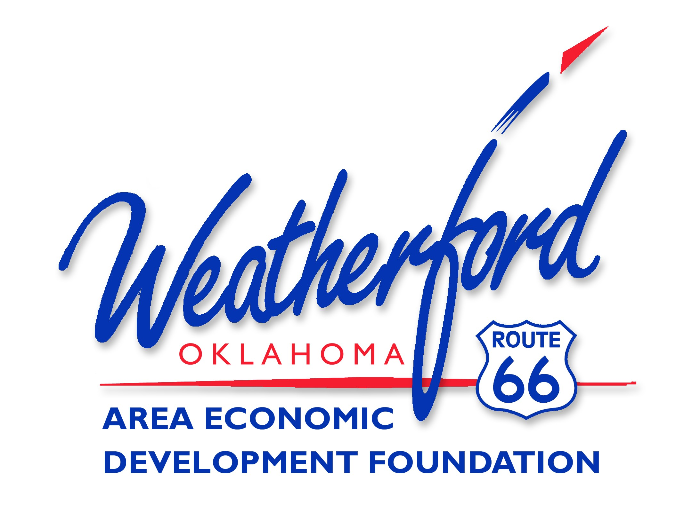

“Doing Business in the Heart of America”

Weatherford Area Economic Development Foundation
2024 Board of Directors

Term Expires December 2024
Derek Roper
Andy McPherson
James Ratcliffe

Term Expires December 2025
Karen Magill
Marrik Vandersee
Lisa Thiessen

Term Expires December 2026
Mike Karlin
Mike Hixson
Heston Wright
Kalie Sheppard

2023 Board Members by Position
Andy McPherson – Chairman
Yolanda Creswell – President
Mike Hixon – Treasurer
Marrik Vandersee– Secretary
Derek Roper – Chairman-Elect
Heston Wright – Past-Chairman

Ex-Officio Board Members
Mike Brown – Mayor, City of Weatherford
Fred Schamburg – Chairman, Weatherford Industrial Trust
Brad Yoder- President, Weatherford Area Chamber of Commerce
Dr. Diana Lovell – President, SWOSU

2024 Executive Committee
Andy McPherson - Chairman Derek Roper– Chairman-Elect
Mike Hixson – Treasurer Marrik Vandersee– Secretary
Heston Wright– Past Chairman

